**ACKNOWLEDGMENT**

First, we would like to thank the Department of Computer Science of Parvatibai Chowgule College Of Arts And Science,for providing us with the opportunity to complete this project. We would like to express our deep gratitude give to our final year project guide, Miss. Priya Lotlikar, whose contribution in suggestions and encouragement, helped us to coordinate our project and especially in writing this report. Furthermore we would also like to acknowledge with much appreciation the staff of Department of Computer Science, who gave the permission and time to allow us to complete our project. A special thanks goes to our friends, classmates and our families who provided us with resources and their encouragement which lead to the successful completion of this project. Lastly, we would like to thank

Table of Contents

ABOUT THE PROJECT 1

UNIT 1 – INTRODUCTION 2

INTRODUCTION 3

UNIT 2 – SYSTEM REQUIREMENTS SPECIFICATION 4

PURPOSE 5

THECHNOLOGY USED 6

MIDDLEWARE TOOLS 7

UNIT 3-DESIGN 15

USE CASE DIAGRAM 16

Use Case Description 17

FLOW DIAGRAM 20

BLOCK DIAGRAM 21

CIRCUIT DIAGRAM 22

UNIT 5 – WORKING OF THE PROJECT 23

WORKING 24

HARDWARE OUTPUT SCREENSHOTS 25

UNIT 6 – FUTURE SCOPE 32

FUTURE SCOPE 33

UNIT 7-CONCLUSION 34

CONCLUSION 35

REFERENCES 36

IMAGE REFERENCES 37

**SMART SAFTEY LOCKER USING ARDUINO**

A project report submitted in partial fulfilment of the requirement for the degree of

**Bachelor of Science**

**In**

**Computer Science**

**By**

**Shreyas Phatak, Zaheed Kazi, Imtiyaz Khan**

Under the supervision of

**Miss. PRIYA LOTLIKAR**

PARVATIBAI CHOWGULES COLLEGE OF ARTS & SCIENCE

AUTONOMOUS

(March 2018)

**DECLARATION BY CANDIDATE(S)**

We declare that this project report has been prepared by us and to the best of our knowledge, it has not previously formed the basis for the award of any diploma or degree by any other University.

|  |  |  |
| --- | --- | --- |
| Roll No. | Name | Signature |
| SU150067 | Phatak Shreyas Shrikant |  |
| SU150111 | Kazi Zaheed |  |
| SU150288 | Khan Mohmed Imtiyaz |  |



**CERTIFICATE BY SUPERVISOR**

Certified that the Project Report is a record of work done by the candidate themselves under my guidance during the period of study and that to the best of my knowledge, it has not previously formed the basis of the award of any degree or diploma of any other University.

Name & Signature

Project Supervisor

***

**WORK RECORD/DIARY**

Name of the Department:________________________________

Name of the Candidate:_________________________________

Subject:_______________________________________

Year:_________

Title of the Project:_______________________________

|  |  |  |  |  |  |
| --- | --- | --- | --- | --- | --- |
| Library/  Laboratory/  Field Work | Description  of work | Date | Time  Spent | Signature  of  Authority | Counter  Signature  of Guide&date |
|  |  |  |  |  |  |
|  |  |  |  |  |  |
|  |  |  |  |  |  |
|  |  |  |  |  |  |
|  |  |  |  |  |  |

1) Signature of the student:

2) Signature of the Guide:

3) Signature of H.O.D.:

**CONSOLIDATED MARKSHEET OF PROJECT WORK**

**Name of the Department: __________________________**

**Name of Examination: ____________ Year: _______**

|  |  |  |  |  |  |  |
| --- | --- | --- | --- | --- | --- | --- |
| No | Roll No. | Name of Candidates | Marks  awarded  by Int. Examiner  (/50) | | Marks  awarded  by Int. Examiner  (/50) | Total  Marks  awarded  (/100) |
|  |  |  | SemV  (15) | SemVI  (15) |  |  |
|  |  |  |  | |  |  |
|  |  |  |  | |  |  |
|  |  |  |  | |  |  |
|  |  |  |  | |  |  |

**External Examiner/ Faculty Council Internal Examiner/Supervisor**

**Place:**

**Date:**

**Checked and Countersigned**

**College Seal**

# ABOUT THE PROJECT

This paper discusses the design and implementation of an electronic door lock/unlock compact system using the arduino platform. This security system enable to lock/unlock the door using a 4x4 Keypad. This system operate on a 4-digit password. If any unknown person does an unsuccessful attempt to enter the password in the system, then arduino controller will send a warning message to preset owner mobile number through the Global System for Mobile (GSM) module and also initiate the buzzer alarm as a warning of unauthorized intrusion. The corresponding instructions will be displayed on the LCD. We have got the good experimental results and promising analysis in all these modules. Hence this project can give effective security in minimal cost.

# UNIT 1 – INTRODUCTION

## INTRODUCTION

In this project we are providing enough security to satisfy the user’s needs. The user will be prompted to enter a password to unlock the door. On successful password entry, the door unlocks enabling him/her to store or restore his/her valuables and a message is sent to the registered user. On the other hand, if the user enters an invalid password then corresponding equivalent message will be displayed and a call is made to the registered mobile number. This project “Smart Safety Locker Using Arduino” can be used to provide enough security in various places like bank lockers, security doors, etc. This project uses an Arduino kit that consists of ATMega 328 which is one of the most popular microcontrollers that consists of 14 digital pins and 6 analog general purpose pins, EEPROM of capacity 1KB,GSM module and a ram of 2KB.

# UNIT 2 – SYSTEM REQUIREMENTS SPECIFICATION

## PURPOSE

Today it is essential to provide the security system employing various sensors and alarm system in residential communities. The degree of security is feeble. So there is a lot of robbery, theft going on in and around the world. So, people fear to keep any of their valuables in their homes. Henceforth, many people prefer to keep it in banks. However, in this insecure world even banks are not too safe enough to satisfy people needs. A common man feels his valuables are secured if there is efficiency in security. Hence this project can give effective security in minimal cost.

## THECHNOLOGY USED

**Arduino Language**

The Arduino language is merely a set of C/C++ functions that can be called from your code. Your sketch undergoes minor changes (e.g. automatic generation of function prototypes) and then is passed directly to a C/C++ compiler. Arduino is an open-source electronics platform based on easy-to-use hardware and software. It’s intended for anyone making interactive projects.

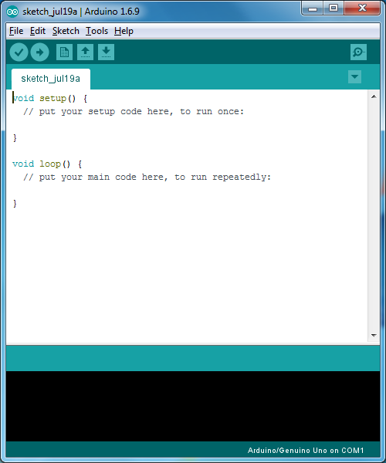

## MIDDLEWARE TOOLS

1. **Arduino UNO**

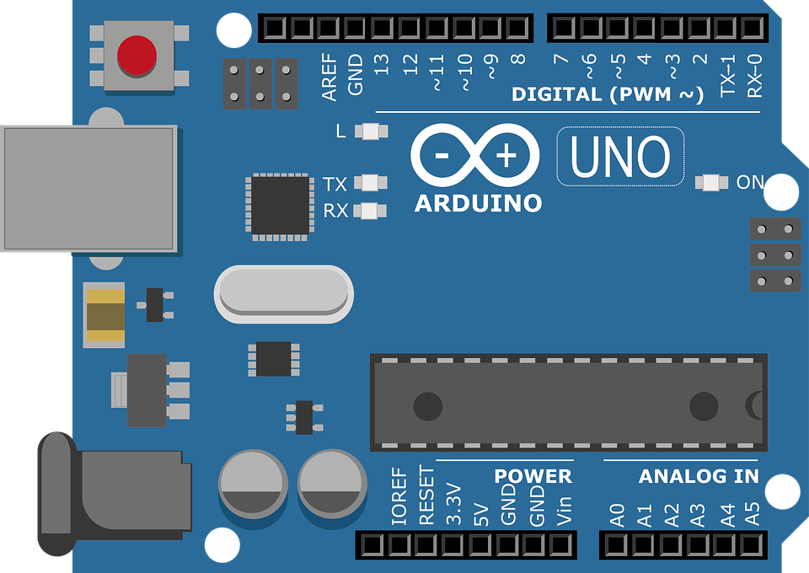

This microcontroller is based on the ATmega 328. There are total of 20 pins (0-19) out of which 6 are analog inputs which can also be used as general purpose pins, a ceramic resonator of frequency 16MHz, an USB connection, a power jack and a reset button. It contains everything needed to support a microcontroller.

Microcontroller ATMega 328

Clock Speed 16MHz

Analog Input pins 6

Digital input output pins 14(6 pins provide PMW voltage)

Input Voltage 6-20V

Operating Voltage 5V

1. **LCD**

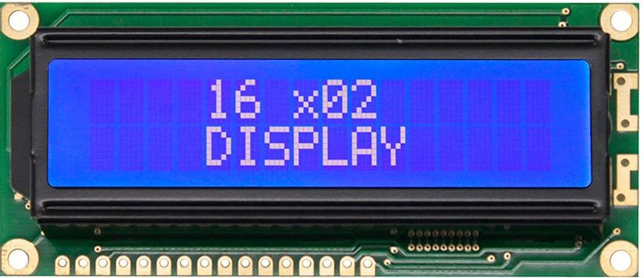

We have used 16x2 liquid crystal display (LCD) for displaying the process, like entering the password, wrong password detection, entering new password, confirming password and to display appropriate message. The library used for programming LCD is <LiquidCrystal.h> I2C LCD has only 4 pins.

PIN SUMMARY

Pin1: VSS

Pin2: Ground

SCL Pin: A4

SDA Pin: A5

1. **Keypad**

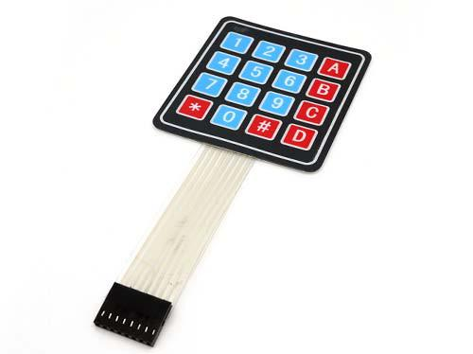

.

We used a 4x4 keypad which has four columns and four rows which are connected to Arduino board. The pass-word will be passed from keypad to the Arduino and Arduino will respond accordingly. This 16 button keypad provides user interface component for Arduino project. this is programmed using the library <keypad.h>. It has the following features:

1 Easy interface to Arduino.

1. Ultra-thin design.
2. Cheap and economical

SUMMARY about Keypad pins:

1. Maximum operation rating: 24VDC, 30 mA.
2. Insulation Resistance : 100M ohm
3. Interface: 8 pins can be accessed in the form of 4X4

matrix.

1. **Servo Motor**

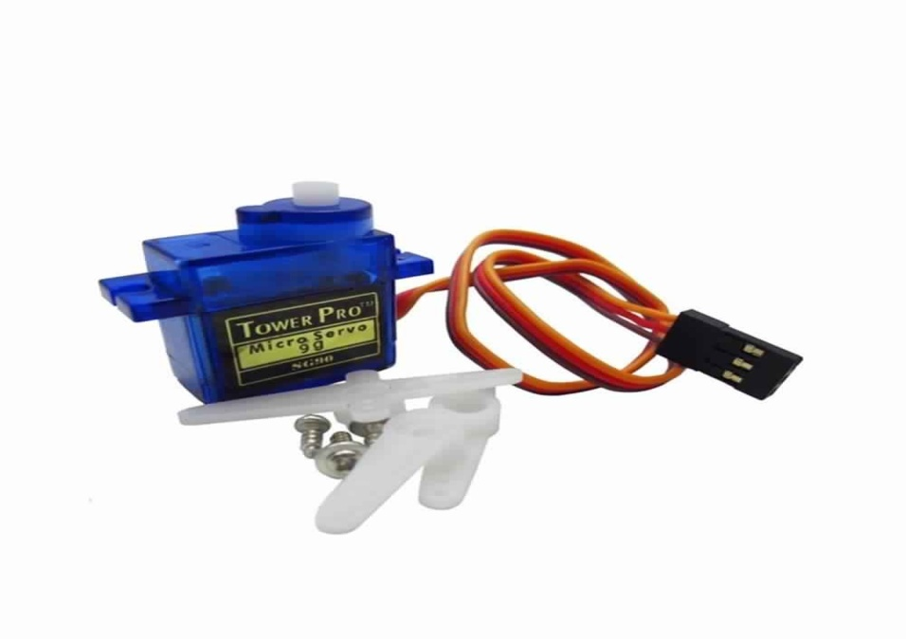

Servos are controlled by sending an electrical pulse of variable width, or pulse widthmodulation (PWM), through the control wire. There is a minimum pulse, a maximum pulse, and a repetition rate. A servo motor can usually only turn 90° in either direction for a total of 180° movement. The motor's neutral position is defined as the position where the servo has the same amount of potential rotation in the both the clockwise or counter-clockwise direction. The servo used in the project is SG90 MicroServo weighing about 12g. This is programmed using the library <servo.h>. It has the following operating conditions:

Modulation Analog

Torque 25.0 oz-in (1.8kg/cm)

Speed 0.12 s/60 deg

Weight 0.32 oz (9.8g)

Motor type 3 pole

Gear type Plastic

Rotation/Support Bushing

Pulse Width 500-2400 micro-sec

1. **BUZZER**

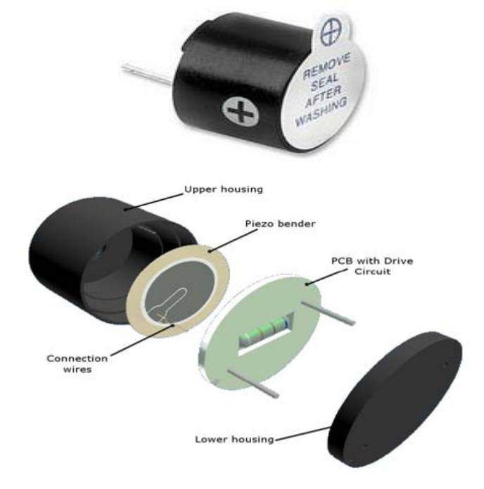

A buzzer or beeper is an audio signalling device. Typical uses of buzzers and beepers include alarm, devices, timers and confirmation of user input such as a mouse click or keystroke. In our project the buzzer is used for beep sound indicating the password entered is incorrect also when the password is changed.

1. **GSM MODULE**

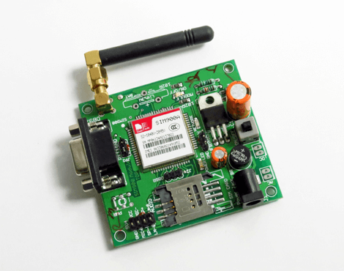

In this project we have used Sim900A GSM module. GSM is a mobile communication modem; it is stands for global system for mobile communication (GSM). This module sends the message to registered user when incorrect password is entered to open the lock. It also sends the message to user when the lock is opened and closed.

**Features of GSM Module:**

* Improved spectrum efficiency
* International roaming
* Compatibility with integrated services digital network (ISDN)
* Support for new services.
* SIM phonebook management
* Fixed dialling number (FDN)
* Real time clock with alarm management
* High-quality speech
* Uses encryption to make phone calls more secure
* Short message service (SMS)

1. **LED**

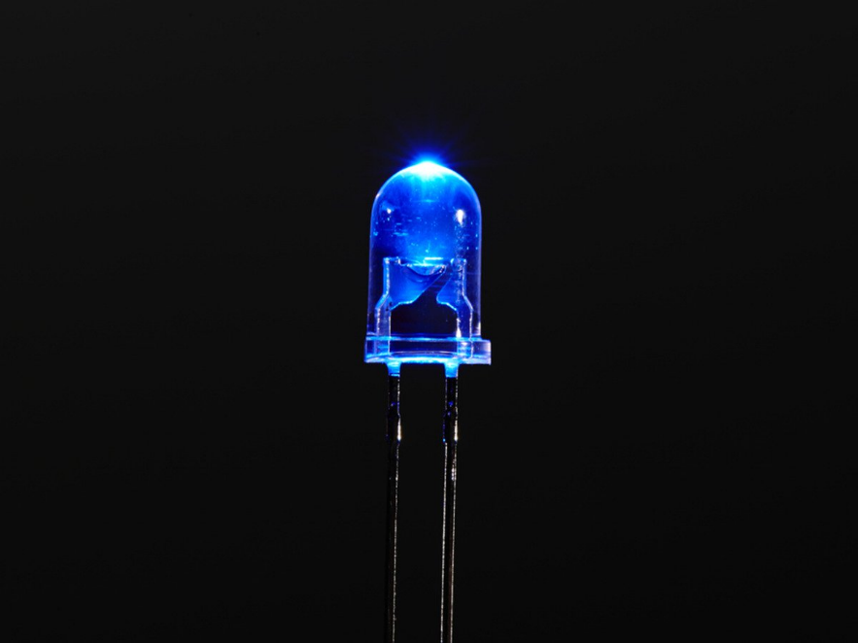

A light-emitting diode (LED) is a two-[lead](https://en.wikipedia.org/wiki/Lead_(electronics)) [semiconductor](https://en.wikipedia.org/wiki/Semiconductor) [light source](https://en.wikipedia.org/wiki/Light_source). It is a [p–n junction](https://en.wikipedia.org/wiki/P%E2%80%93n_junction) [diode](https://en.wikipedia.org/wiki/Diode) that emits light when activated.

1. **JUMPER WIRES**

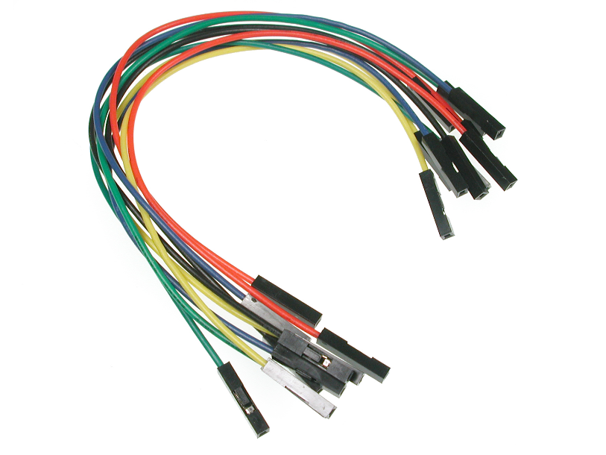

A jump wire (also known as jumper, jumper wire, jumper cable, [DuPont](https://en.wikipedia.org/wiki/DuPont) wire, or DuPont cable) is an [electrical wire](https://en.wikipedia.org/wiki/Electrical_wire) or group of them in a cable with a connector or pin at each end (or sometimes without them – simply "tinned"), which is normally used to interconnect the components of a [breadboard](https://en.wikipedia.org/wiki/Breadboard) or other prototype or test circuit, internally or with other equipment or components, without soldering. Individual jump wires are fitted by inserting their "end connectors" into the slots provided in a breadboard, the [header connector](https://en.wikipedia.org/wiki/Pin_header#Header_connector) of a circuit board, or a piece of test equipment. It is used to connect all the components to Arduino. There are different types of jumper wires. Some have the same type of [electrical connector](https://en.wikipedia.org/wiki/Electrical_connector) at both ends, while others have different connectors.

# UNIT 3-DESIGN

## USE CASE DIAGRAM

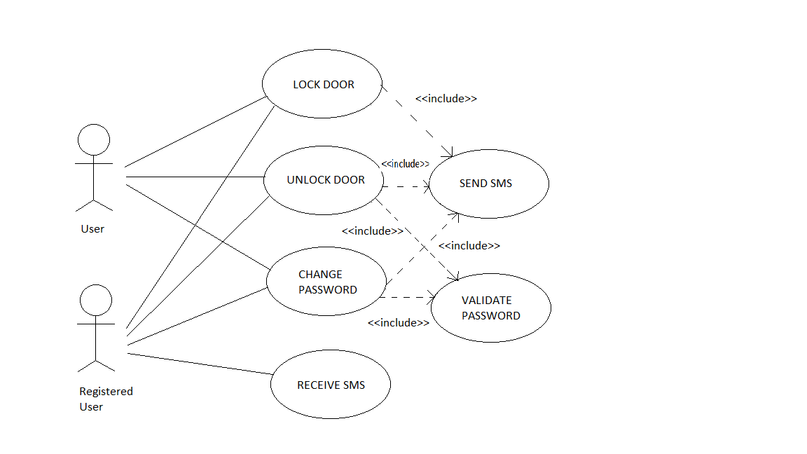

### Use Case Description

**Use Case:-** Lock Door

**Primary Actor:-** User, Registered User

**Stakeholder & Interest:**Registered User, User, User wants to lock the door.

**Pre-condition:** The locker is unlocked

**Post-condition:**The locker is locked.

**Main Success Scenario(Basic Flow):-**

1. User enters the password through keypad.
2. The password is verified and the locker is opened.
3. User presses the ‘B’ button and closes the locker.
4. Corresponding equivalent message is sent to the registered user.

**Extension(Alternate flow):-**

2a. Invalid Password.

**Use Case:-** Unlock Door

**Primary Actor:-** User, Registered User

**Stakeholder & Interest:**Registered User, User, User wants to Unlock the door.

**Pre-condition:** The locker is locked.

**Post-condition:**The locker is unlocked.

**Main Success Scenario(Basic Flow):-**

1. User enters the password through keypad.
2. The password is verified and the locker is opened.
3. Corresponding equivalent message is sent to the registered user.

**Extension(Alternate flow):-**

2a. Invalid Password.

**Use Case:-**Change Password

**Primary Actor:-** User, Registered User

**Stakeholder & Interest:** Registered User, User, User wants to change the password.

**Pre-condition:** The locker is unlocked.

**Post-condition:**Password has been changed.

**Main Success Scenario(Basic Flow):-**

1. User enters the password through keypad.
2. The password is verified and the locker is opened.
3. User presses the ‘#’ button to change the password and enters the current and the new password.
4. Corresponding equivalent message is sent to the registered user.

**Extension(Alternate flow):-**

2a. Invalid Password.

3a. Invalid Current password.

**Use Case:-**Receive SMS

**Primary Actor:-**Registered User

**Stakeholder & Interest:**Registered User, Registered User receives SMS.

**Pre-condition:** The locker is unlocked, locked, or the password has been changed.

**Post-condition:**Registered User has successfully received the SMS.

**Main Success Scenario(Basic Flow):-**

1. User enters the password through keypad.
2. The password is verified and the locker is opened and corresponding equivalent message is received by the registered user.
3. User presses the ‘B’ button and closes the locker and corresponding equivalent message is received by the registered user.
4. User presses the ‘#’ button to change the password and enters the current and the new passwordand corresponding equivalent message is received by the registered user.

**Extension (Alternate flow):-**

2a. Invalid Password.

3a. Invalid Current password.

## FLOW DIAGRAM

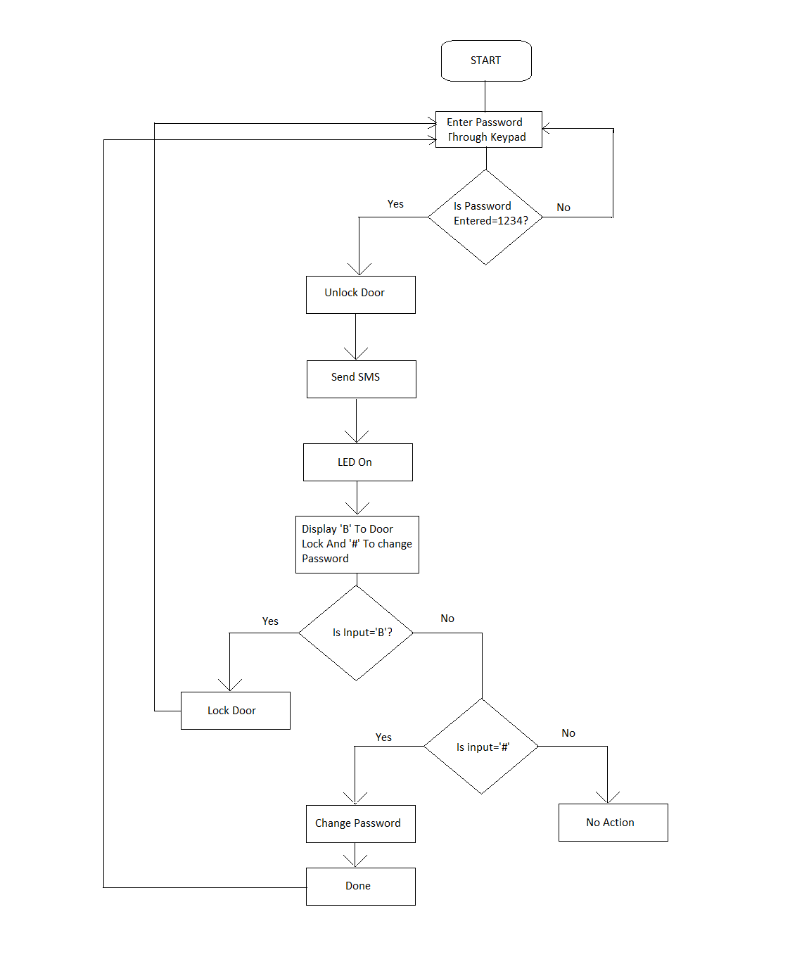

## BLOCK DIAGRAM

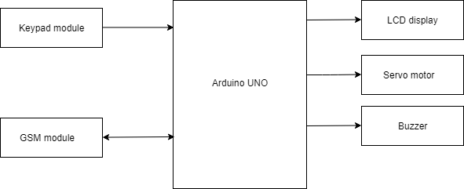

## CIRCUIT DIAGRAM

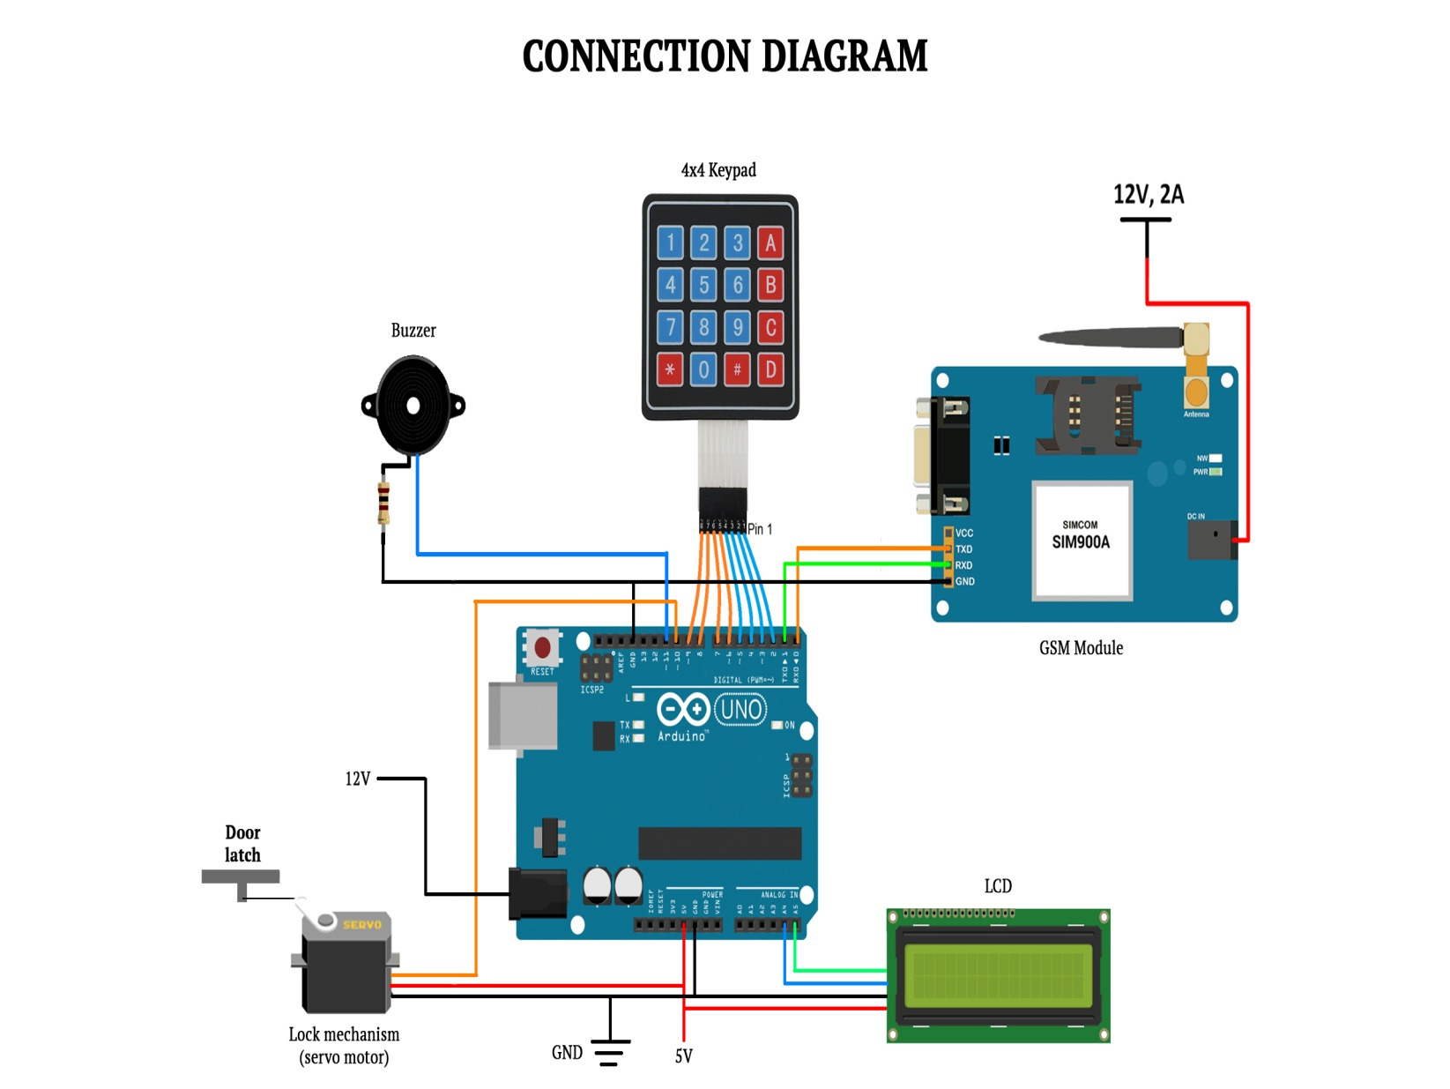

# UNIT 5 – WORKING OF THE PROJECT

## WORKING

The circuit diagram shows the connection of the components of project “Smart Safety Locker Using Arduino”. Initially the passkey is predefined. When the device is switched on user is asked to enter the passkey using the 4x4 keypad which is read by Arduino.The entered passkey is checked with the predefined passkey. If the passkey matches, then the servo motor deflects and the lock is opened, and a message will be send to user using GSM module. If the passkey does not match it will give appropriate message and the buzzer will start buzzing for 3 times. User is also given with option to change the passkey by pressing # key. And when you press the B key the lock will be closed.

## HARDWARE OUTPUT SCREENSHOTS

1. To Enter the password

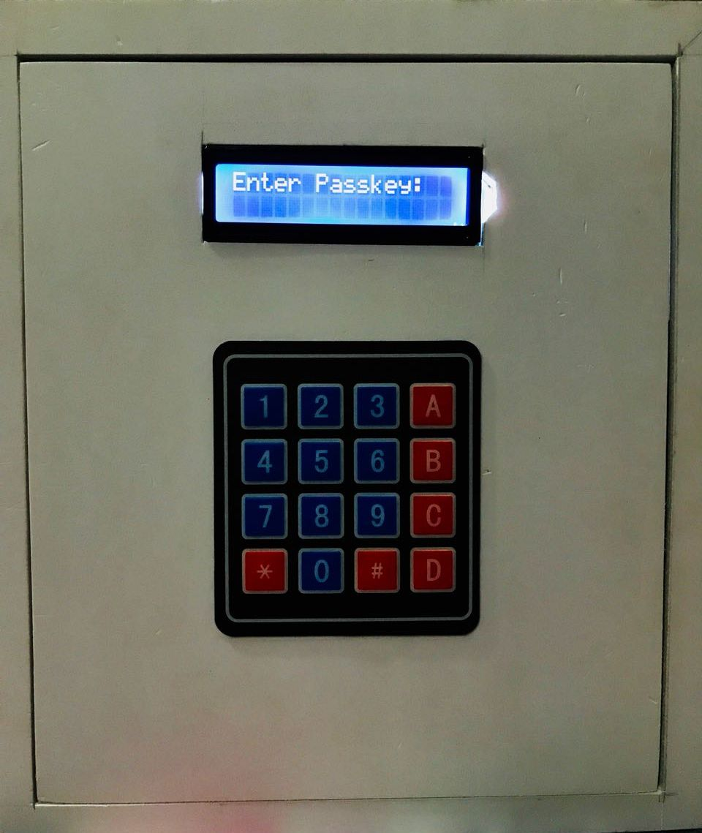

1. Password displayed

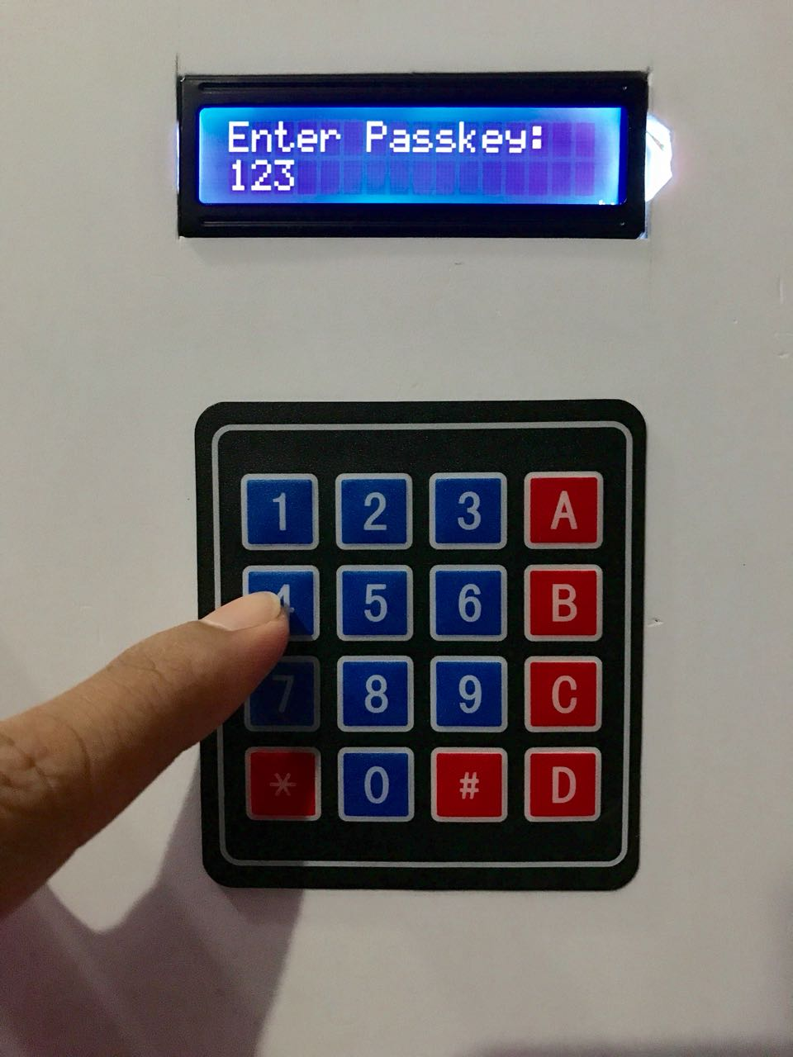

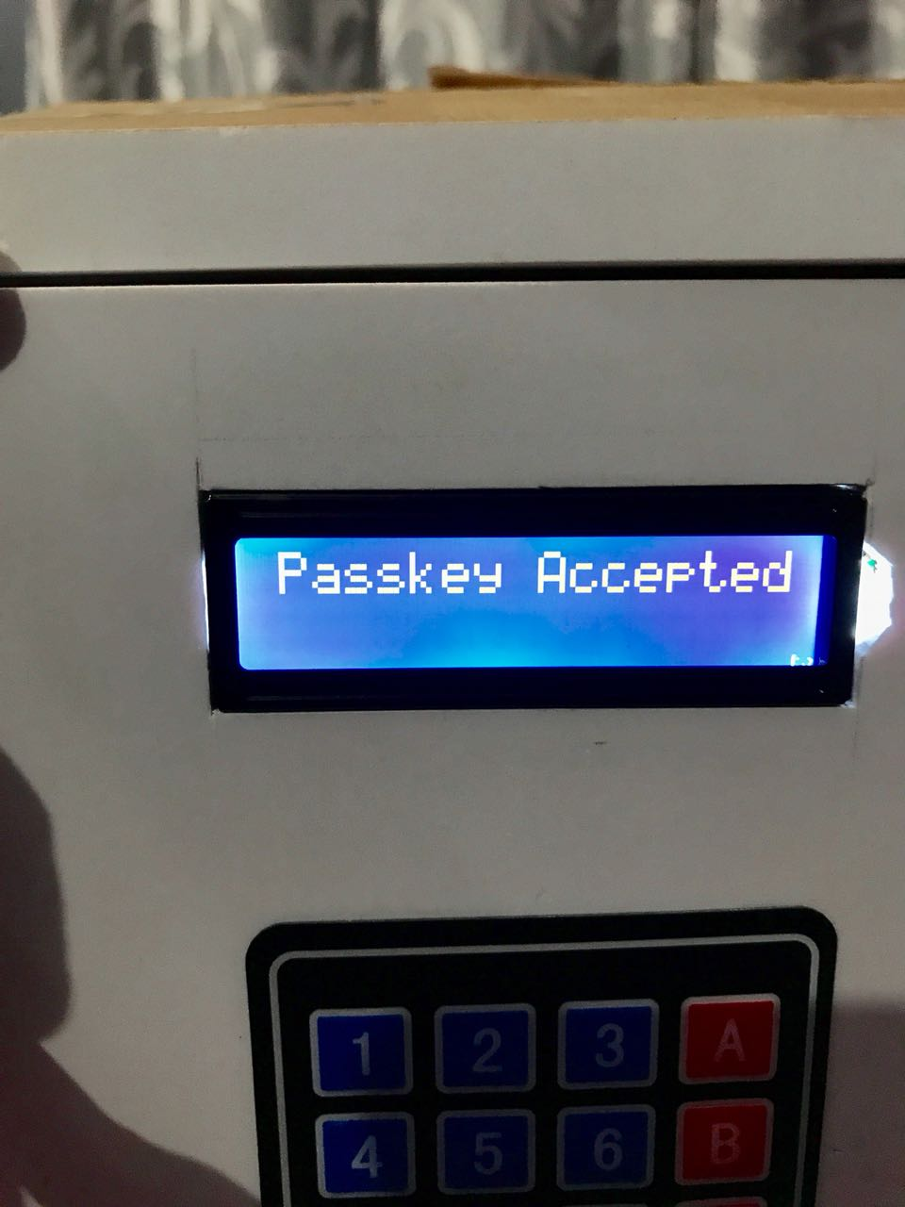

1. Lock opened

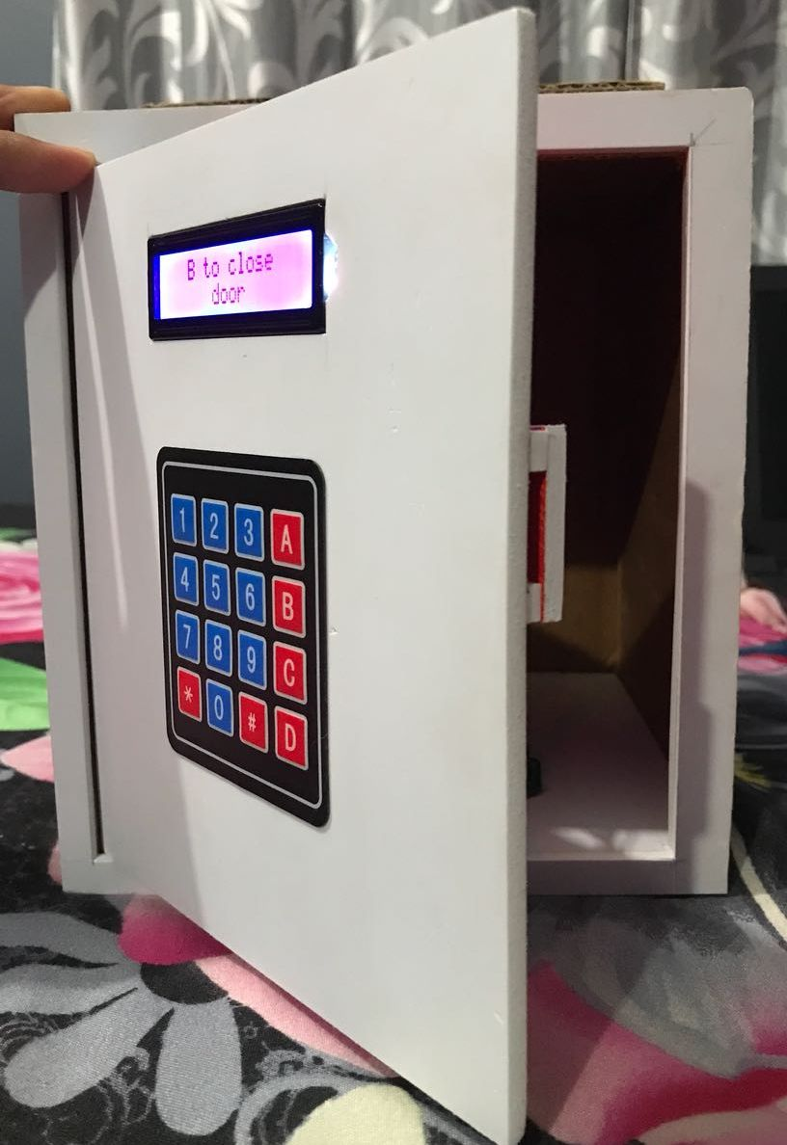

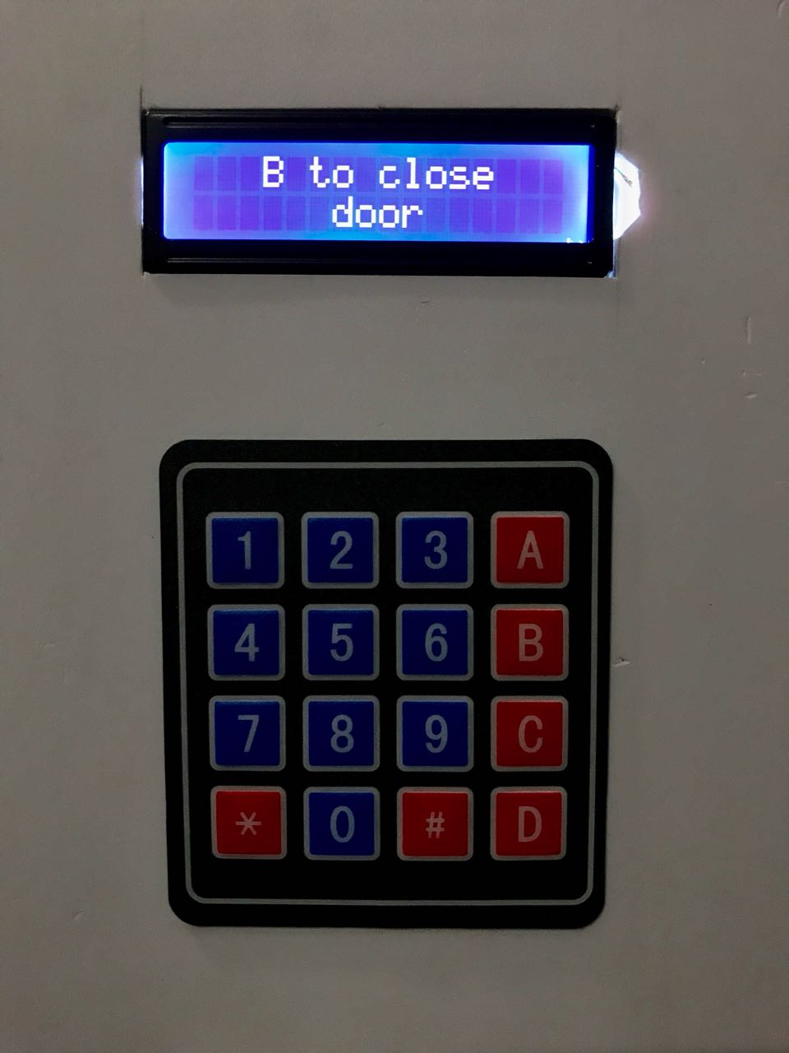

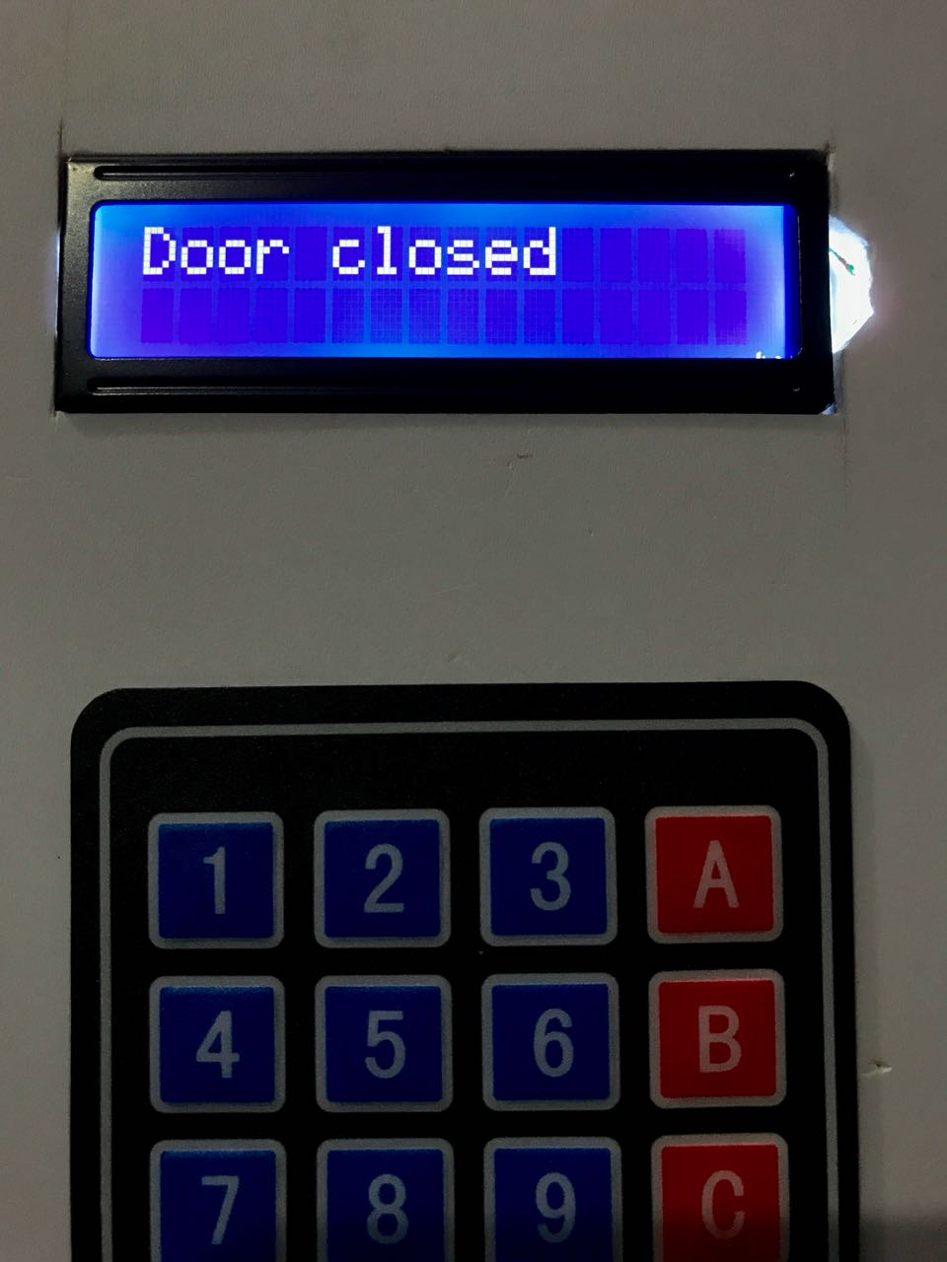

1. Change password

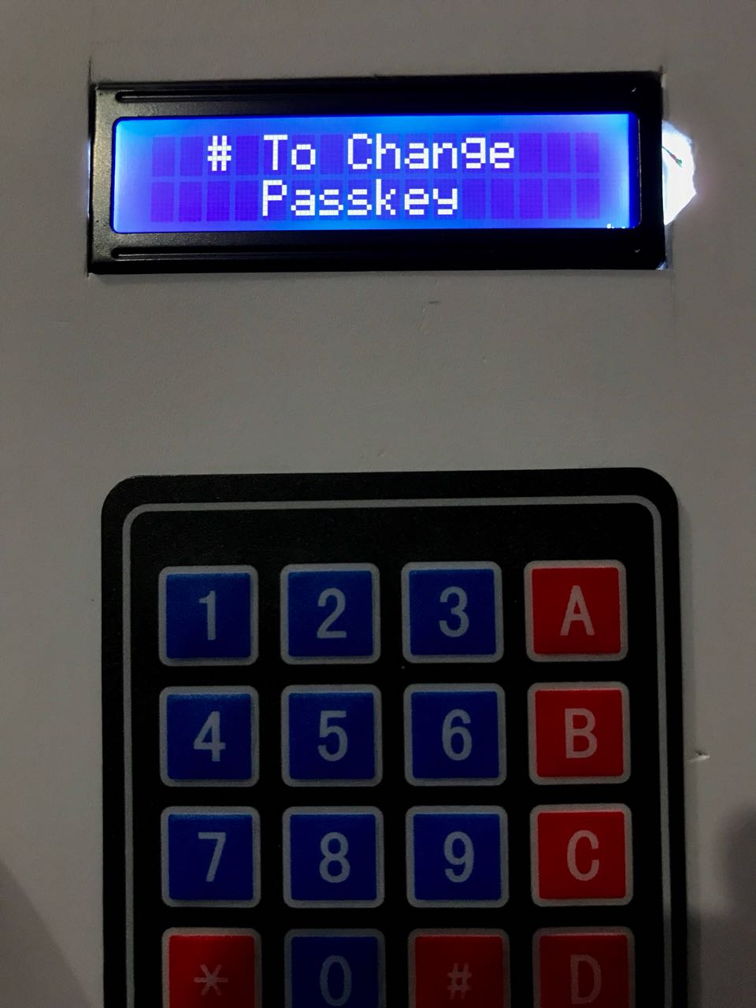

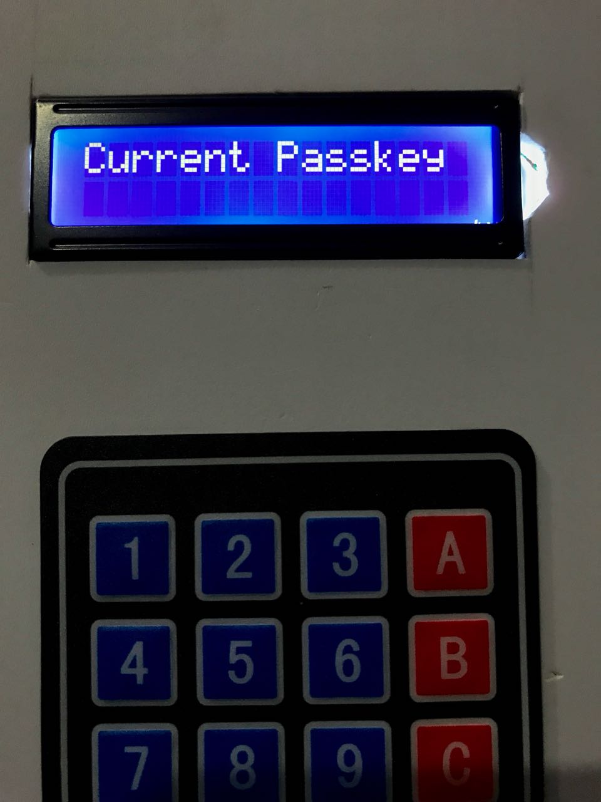

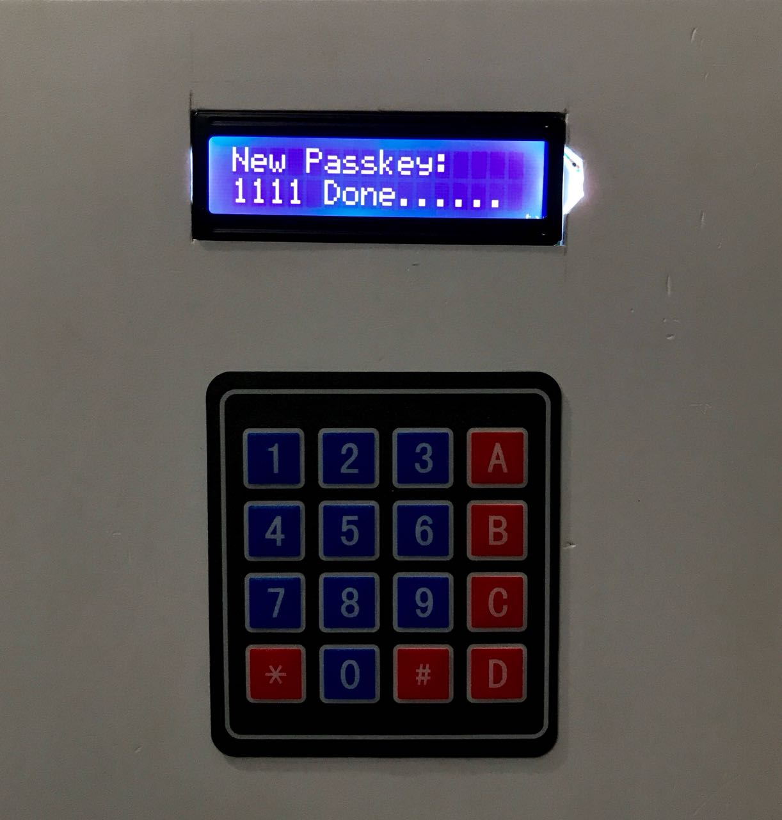

# UNIT 6 – FUTURE SCOPE

## FUTURE SCOPE

Although our system has been completed it is not perfect, security of the System can be improved in the future. The future plans which are envisioned for the system are the following:

* Bluetooth module can be added to system. It will allow user to open the lock using the mobile phone. It will increase the security of the system. It will also provide alternate way to open the lock in case of hardware malfunction.

# UNIT 7-CONCLUSION

## CONCLUSION

This project is effective in providing enough security as long as the passkey is not shared. In future this “Arduino based password security locking system” can be provided maximum security by the above enhancements in order to completely satisfy user’s needs. Hence, a common man can afford to purchase such locking system in minimal cost to keep his valuables safely without any worries.

# REFERENCES

[1]Website: <https://circuits4you.com/2016/06/15/gsm-modem-interfacing-arduino/>

[2]Website: <http://arduino.cc/tutorial>

[3] Website <http://instructables.com>

[4]Website: <http://www.alarm.org/HomeSafety/FastFacts.aspx>

[5]Website: <http://airef.org/burglars-confirm-value-of-alarms>

# IMAGE REFERENCES

LCD:

<http://www.winstar.com.tw/uploads/photos/character-lcd-display-modules/WH1602J-TMI.jpg>

Servo motor: <http://mybotic.com.my/webshaper/pcm/gallery/lg/585eba793675c320b04d0f38d9d17f601469678765-lg.jpg>

Arduino uno:

<https://cdn.pixabay.com/photo/2017/03/23/12/32/arduino-2168193_960_720.png>

Buzzer:

<https://www.pcboard.ca/image/catalog/products/buzzers/piezo-buzzer/piezo-buzzer-specs.jpg>

Keypad :

<http://fb1-cu.lnwfile.com/myh0zf.jpg>

GSM Module :

<https://cdn.shopify.com/s/files/1/1723/8439/products/TECH1506_a_large.png?v=1492143940>